**GIT PROCEDURE**

Step1: For particular Folder, right click and open the Git bash here, so get the window like below

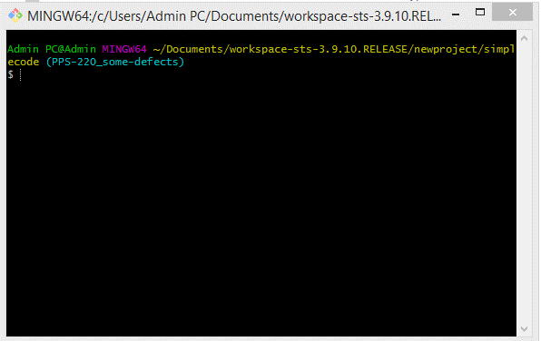

Step2: Git Clone <URL>

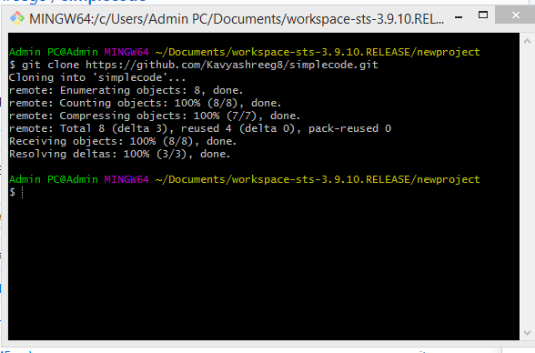

Step3: Creat Readme2.md

Step4: cd <Repository Name>

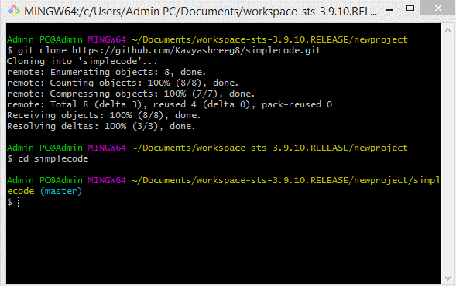

Step4: git checkout –b “branch name”

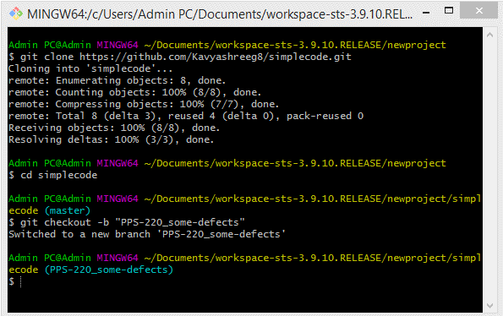

Step6: Copy and paste ReadMe2.md to simple code(repository folder)

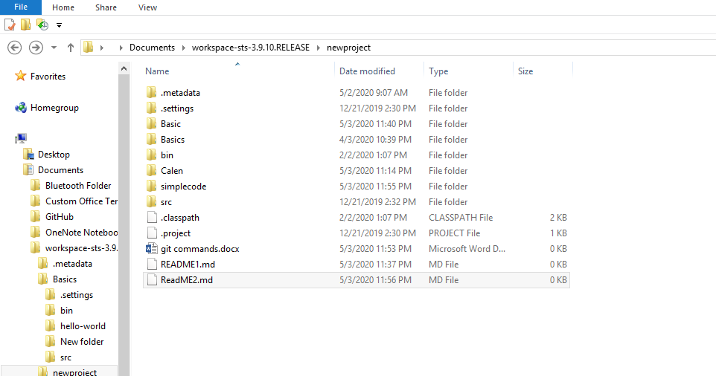

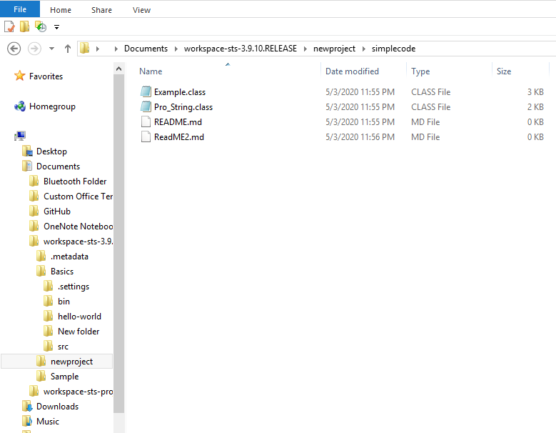

Step7 : Use git ReadMe2.md or git add . (to add all the file)

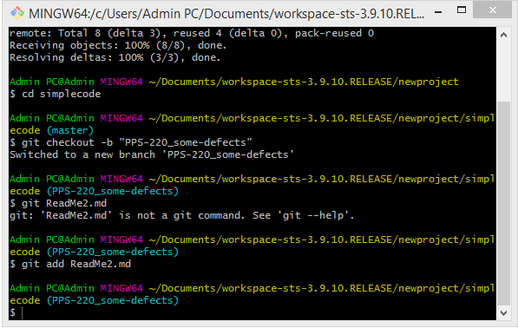

Step8 : git commit –m “add some commit”

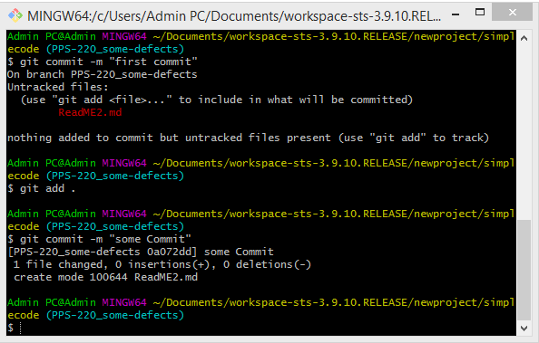

Step 9 : git push origin “branch name”

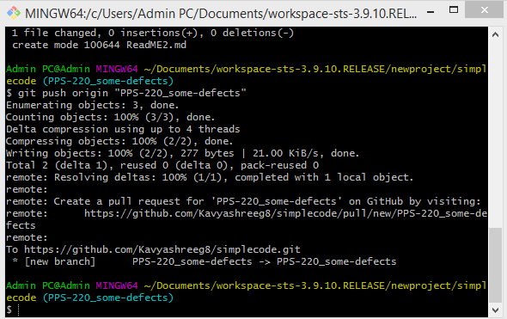

Step 10 –click on compare & pull request option and create pull request

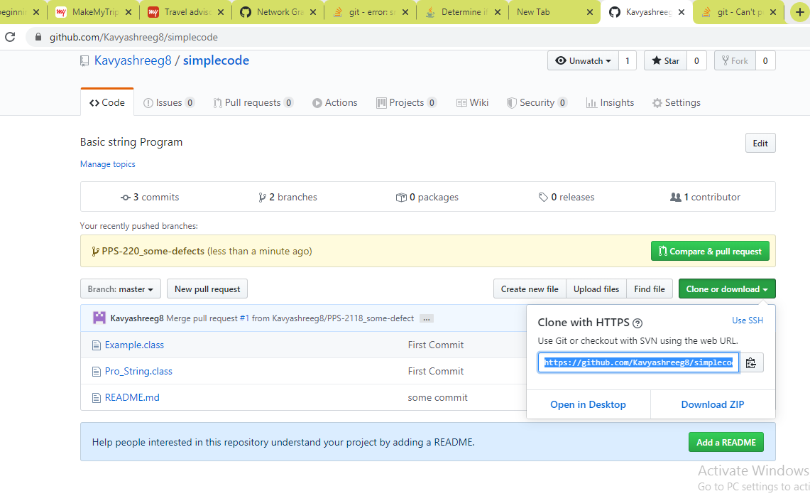

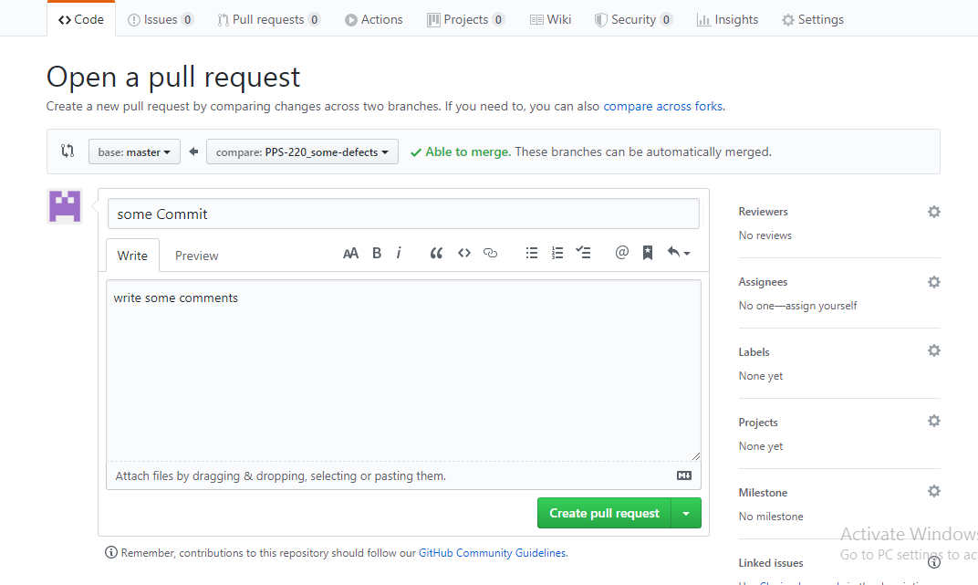

Step 11: For Merging, click on merge pull request and confirm merge

